Name: Khushi Nitinkumar Patel

PRN: 2020BTECS00037

Batch: T2

**Assignment No 2**

# ## Types and Type Safety

1. Declare two variables, one called `firstDecimal` and one called `secondDecimal`. Both should have decimal values. Look at both of their types by holding Option and clicking the variable name.

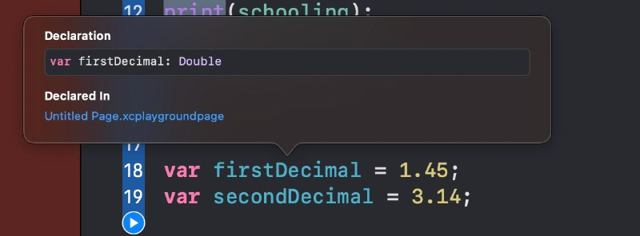

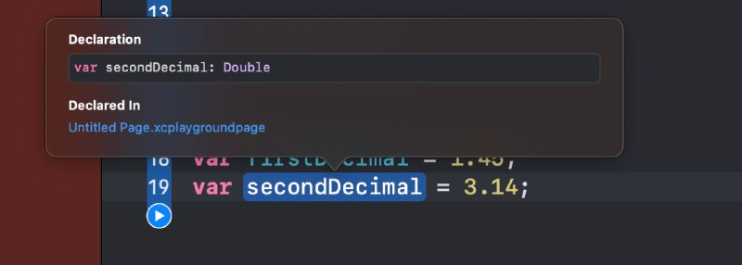

1. Declare a variable called `trueOrFalse` and give it a boolean value. Try to assign it to `firstDecimal` like so: `firstDecimal = trueOrFalse`. Does it compile? Print a statement to the console explaining why not, and remove the line of code that will not compile.

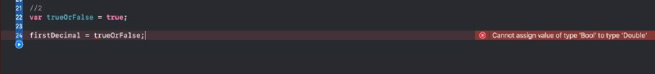

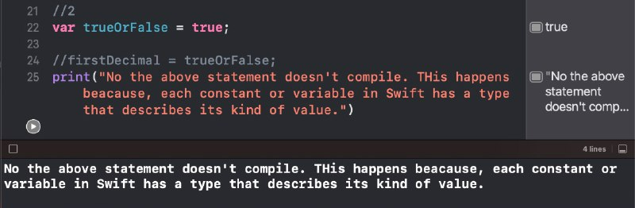

1. Declare a variable and give it a string value. Then try to assign it to `firstDecimal`. Does it compile? Print a statement to the console explaining why not, and remove the line of code that will not compile.

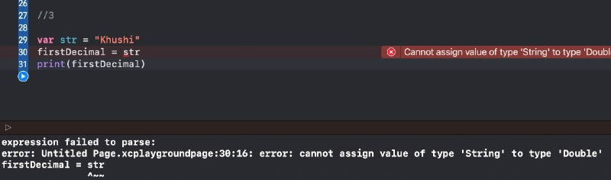

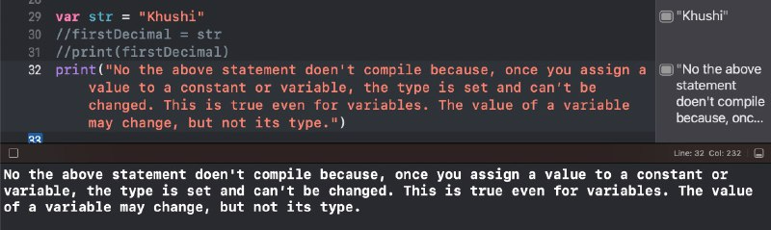

1. Finally, declare a variable with a whole number value. Then try to assign it to `firstDecimal`. Why won't this compile even though both variables are numbers? Print a statement to the console explaining why not, and remove the line of code that will not compile.

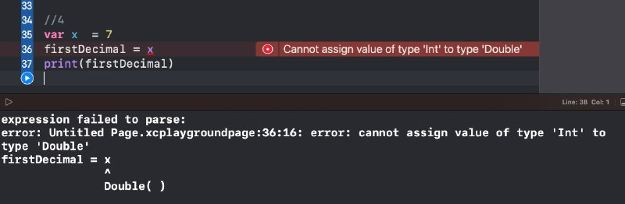

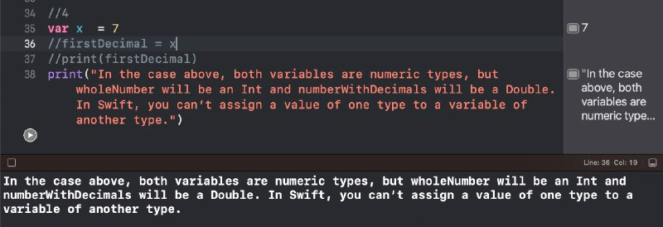

1. You have declared a number of constants and variables to keep track of fitness information. Declare one more variable with a boolean value called `hasMetStepGoal`.

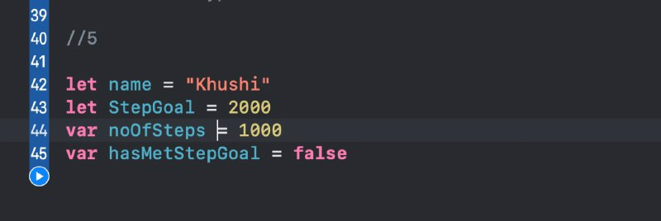

1. When you declared a constant for goal number of steps and a variable for current step count, you likely assigned each a value in the thousands. This can be difficult to read. Redeclare this constant and variable and, when assigning each a value in the thousands, format the number so that it is more readable.

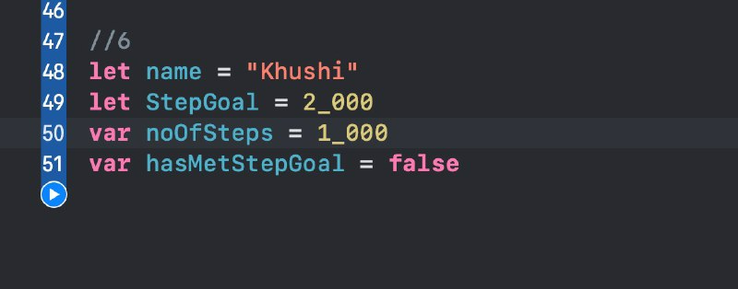

# ## Type Inference and Required Values

1. Declare a variable called `name` of type `String`, but do not give it a value. Print `name` to the console. Does the code compile? Remove any code that will not compile.

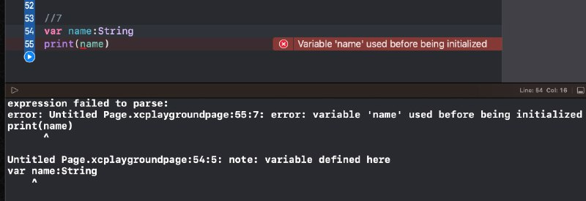

1. Declare a variable called `distanceTraveled` and set it to 0. Do not give it an explicit type.

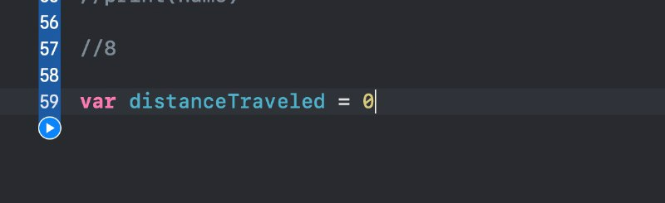

1. Now assign a value of 54.3 to `distanceTraveled`. Does the code compile? Go back and set an explicit type on `distanceTraveled` so the code will compile.

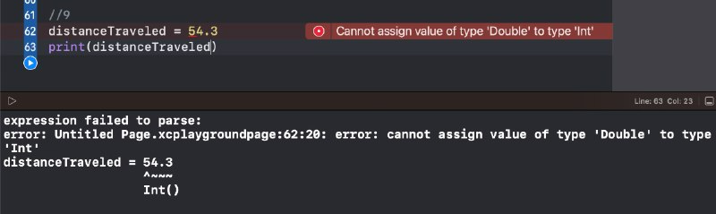

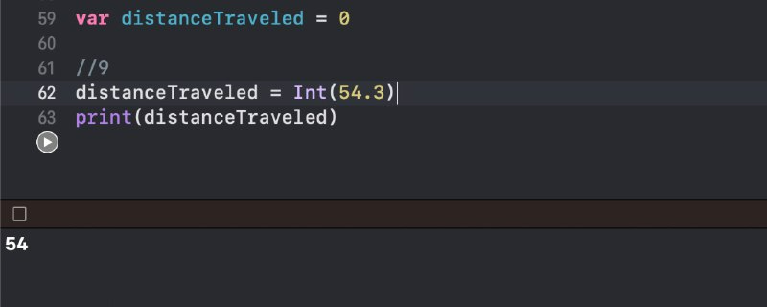

1. You decide that your fitness tracking app should show the user what percentage of his/her goal has been achieved so far today. Declare a variable called `percentCompleted` and set it to 0. Do not explicity assign it a type.

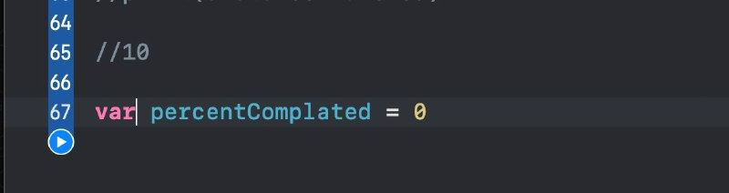

1. Imagine that partway through the day a user has taken 3,467 steps out of the 10,000 step goal. This means he/she is 34.67% of the way to his/her goal. Assign 34.67 to `percentCompleted`. Does the code compile? Go back and explicity assign a type to `percentCompleted` that will allow the code to compile.

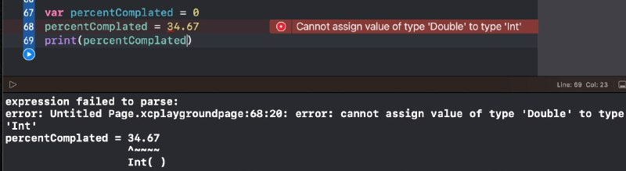

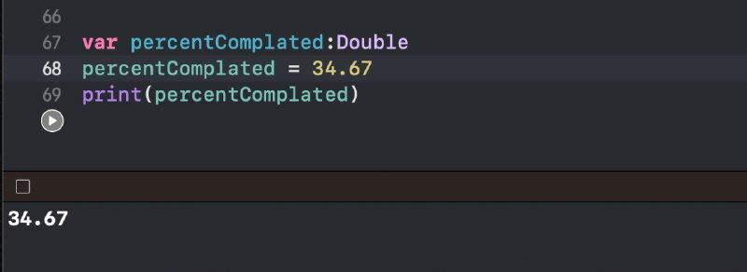

**## Application design workbook**

1. 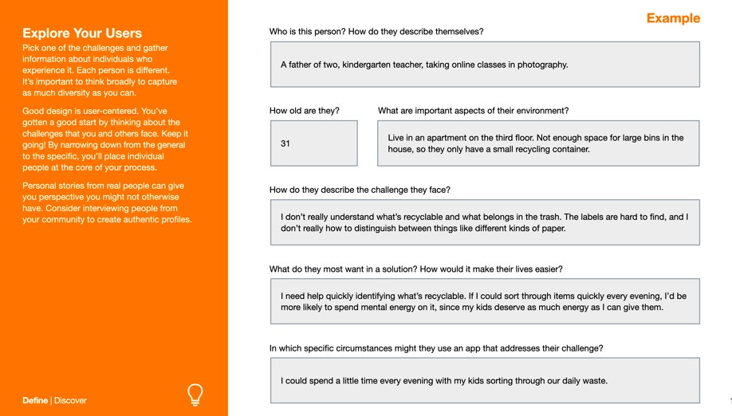**Explore your users**
2. **Consider diversity**

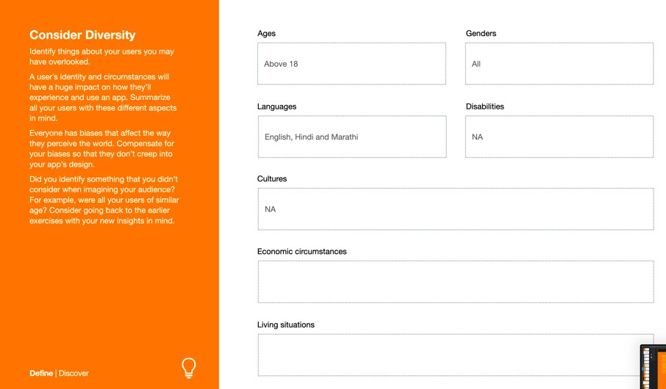

1. **Summarize your audience**

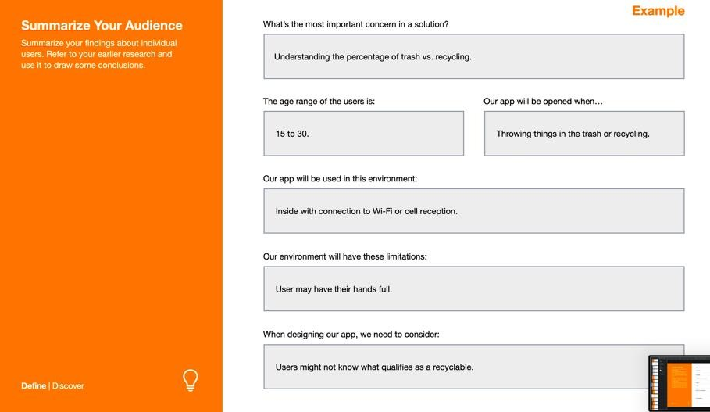

1. **Analyze causes**

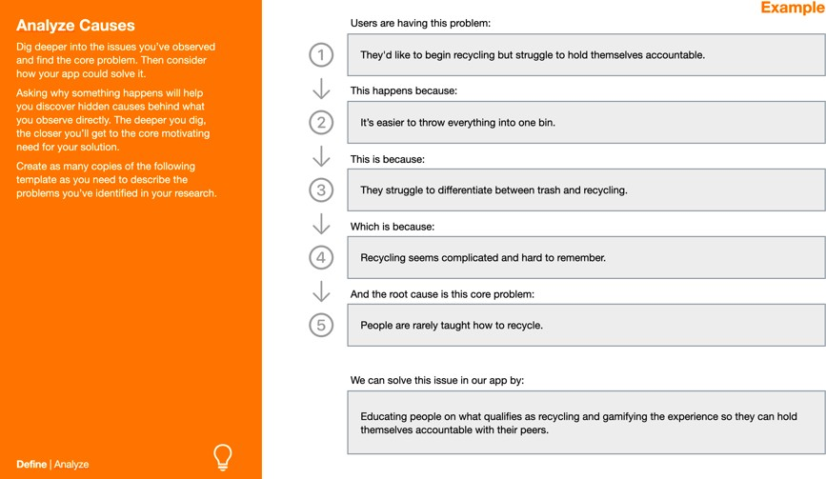

1. **Research Competitors**

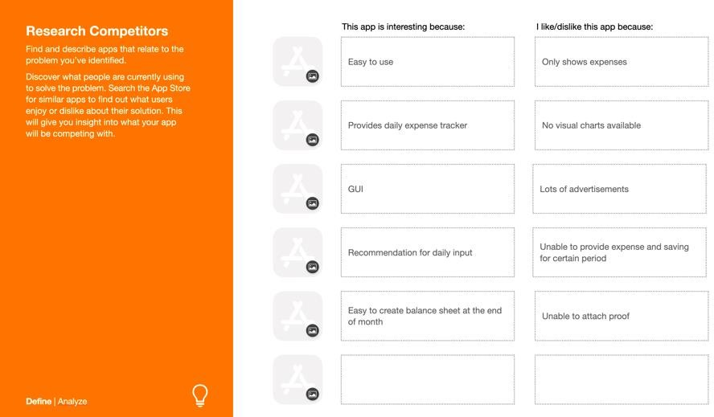

**# Explore your users**

**Who is the person? How do they describe themselves?**

An ordinary person who likes listening to music.

**How old are they?**

20

**What are important aspects of their environment?**

Likes listening to music but cannot find a proper playlists of songs to listen to according  to their mood and language preference.

**How do they describe the challenge they face?**

I can't find a playlist that I would like to listen to, depending upon my mood.

**What do they most want in the solution? How would it make their lives easier?**

I need multiple options of a person's mood and after clicking the option I would be redirected to a playlist containing all the songs suitable to my mood and according to my language preference.

**In which specific circumstances might they use an app that addresses their challenge?**

After an exhausting day of work I can listen to a playlist of songs depending upon my mood.

**# Consider diversity**

1. **Ages:** 18 and above.
2. **Languages:** No language barrier
3. **Disabilities:** NA
4. **Cultures:** NA
5. **Economic circumstances:**
6. **Living situations:**

**# Summarize your audience**

**What’s the most important concern in a solution?**

Understanding the taste of the user in music according to his/her mood.

**The age range of the users is:**

18 and above

**Our app will be opened when..**

User wants to play a particular playlist of songs that can help him/her to handle their mood/emotions.

**Our app will be used in this environment:**

Everywhere with connection to Wi-Fi or Internet data.

**Our environment will have these limitations:**

NA

**When designing our app we need to consider:**

Users might not know about the playlist that can handle their current emotions.

**# Analyse causes**

**Users are having this problem:**

 They’d like to listen to a playlist of songs depending on their mood but cannot find one**.**

**This happens because:**

  It’s difficult to find a playlist related to their current mood.

**This is because**

 They struggle to find songs related to their current mood.

**Which is because**

Sorting songs in a playlist of a particular genre or  feeling or emotion seems time  consuming.

**And the root cause is this core problem:**

 People need quick access to a playlist which can support their mood.

**We can solve this issue in our app by:**

Creating multiple options of user’s emotions for example: sad, happy, angry, lonely, etc. Which can give quick access to a playlist of user’s choice of mood.